DHSS Job Aid 25: How to Check Leave Balances

Employees can check their leave balances at any time in eSTAR by using the Leave tab found on the timesheet. After logging into the system, open the timesheet by selecting My Timesheet from the Time Entry area of the home screen.

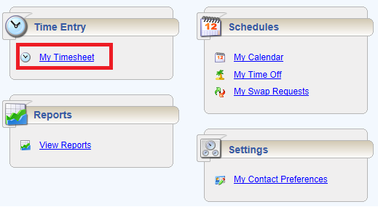

The following is an example of an employee time entry window.

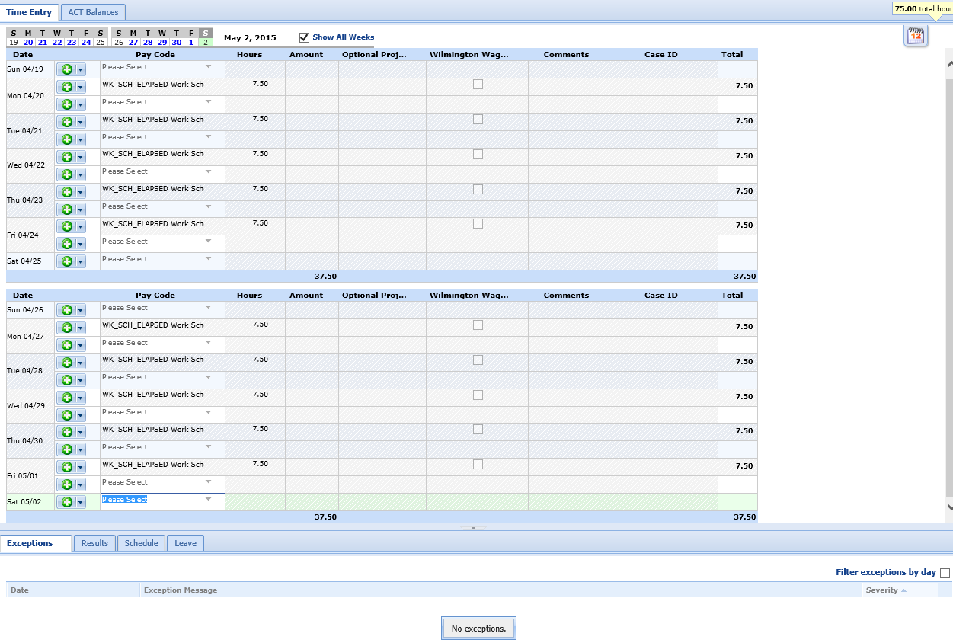
Use the Calendar function in the upper left hand corner of the timesheet to see how much leave is available for selected date.
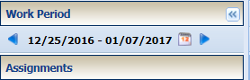

After locating the Calendar function, click on the picture to select desired dates.

After clicking on the Calendar, select the desired date. This will take you to the timesheet for the date selected.
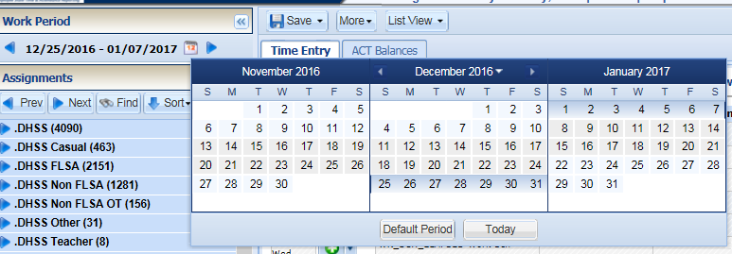

Select the Leave at the bottom of the page to view leave balances. Under the Leave tab, the Annual, Sick, Comp Time and Floating Holiday balances can be viewed.

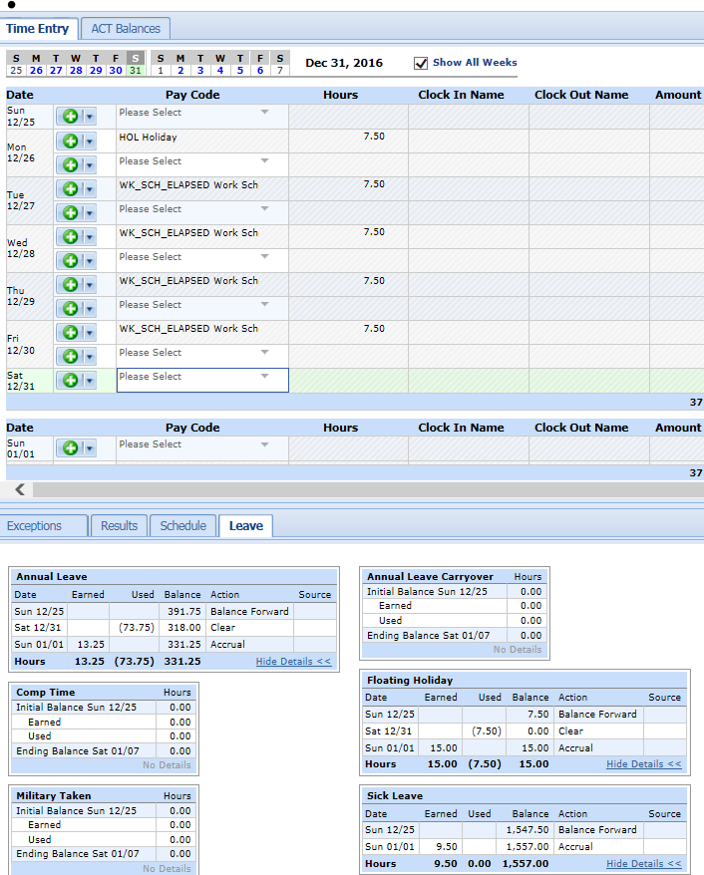
The leave balance boxes show the balances for the pay period selected.

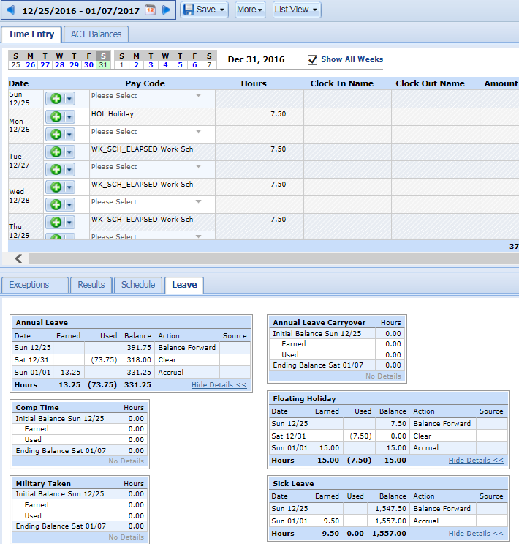
At the end of each year, per Merit Rule 5.2.4, employees may only carryover a maximum of 318 hours of Annual leave. If employees are at risk of losing time due to having greater than 318 hours, eSTAR will show the number of hours to be lost with the word Clear in the Action box next to the number of hours. In the example below, if not taken prior to 12/31, the employee will lose 73.75 hours. The Annual Leave box shows the employee has a balance of 391.75 hours of Annual Leave as of 12/25. The employee will lose 73.75 hours on 12/31 if not used before 12/31. The 13.25 hours on 01/01 are accrued on 1/1 and are not affected by this rule.

