DHSS Job Aid 12: Managing your Approved FMLA Case and Using the ACT Dashboard
Once your FMLA request has been approved, you can review it. From the home screen, select Schedules and My Time Off.

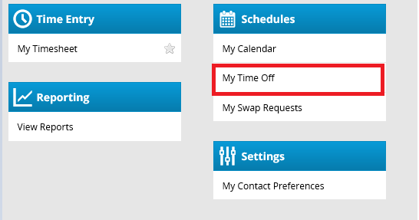
Your FMLA cases(s) will appear in your Request List. Click on the case you would like to view.

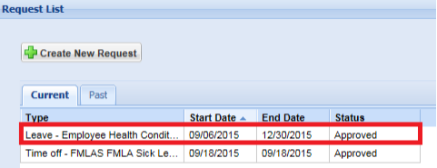

The FMLA dashboard illustrates details about your FMLA case. You can add more than one email address, update your mailing address, add a comment to your case, view comments from your ACT Case Manager, upload a document, and view your FMLA leave balance. Any information you submit is kept confidential and secure.

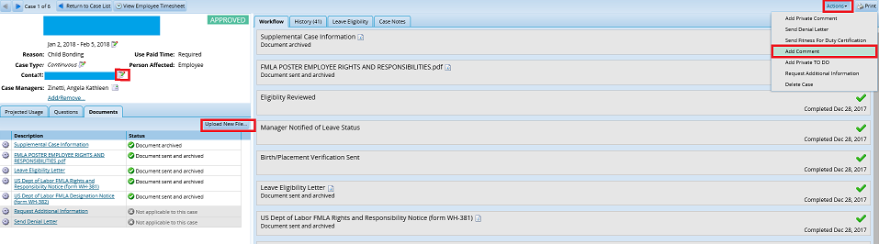

Click on Questions. This tab displays answers you provided to questions you were asked when applying for FMLA. You may only change your responses when your case remains in a pending or open status.

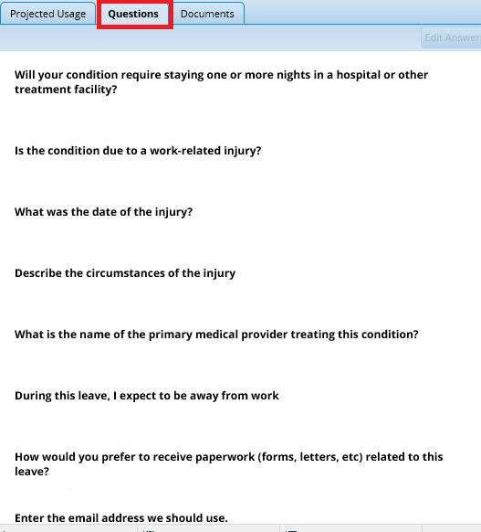

Click on Projected Usage. The Projected Usage tab will display your start balance, allowed period, end balance, and leave type. Click on View Usage Summary in order to view more details regarding your FMLA allowance.

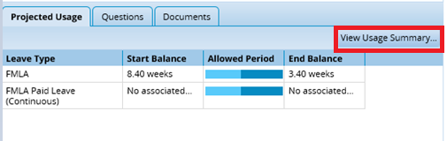

The Usage By Leave Type table shows the past, current, and future use of FMLA. Hover your mouse on the blue and purple line. Your FMLA case number with actual and projected FMLA usage dates will appear.

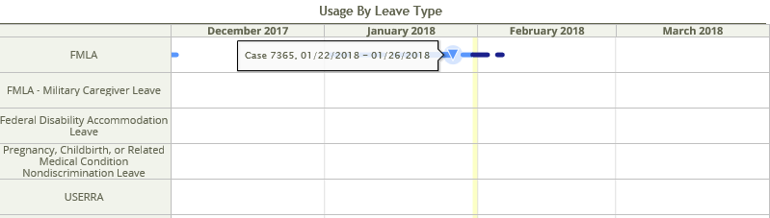

The FMLA Allowance graph displays both actual and projected FMLA usage.

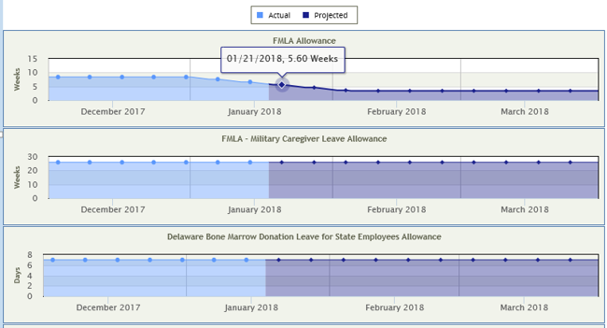

Log into eSTAR in order to view FMLA hours used and available paid leave on your timesheet. Click on My Timesheet.

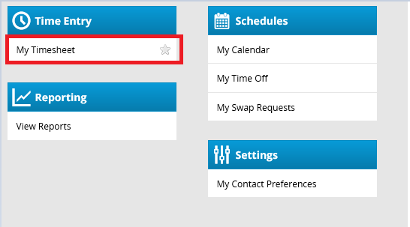

Timesheets: Tracking FMLA and paying available leave during FMLA.

The LOA Leave of Absence paycode tracks FMLA hours. This paycode should never be removed from the timesheet by managers or auditors.

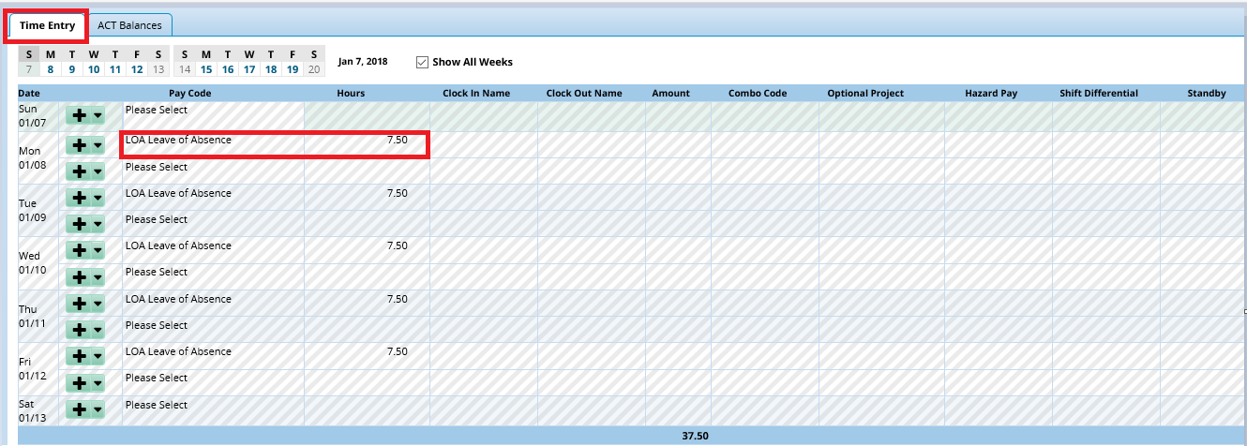

All FMLA cases have a case number assigned to them, and this will appear on the timesheet.

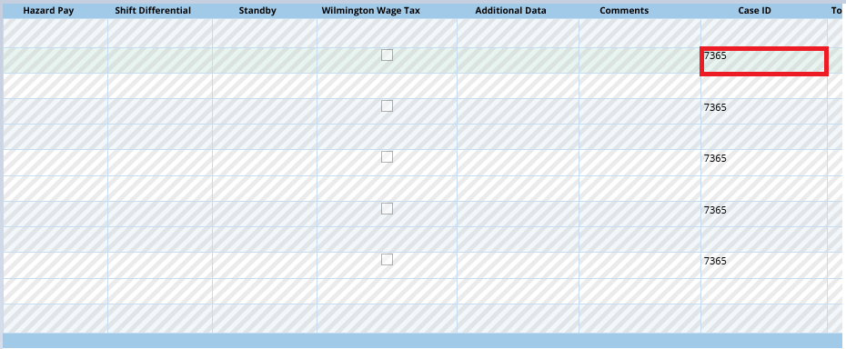

The ACT module automatically decrements available leave for FMLA continuous cases. Leave is decremented in the following order: Sick leave, annual leave, floating holiday, compensatory time.

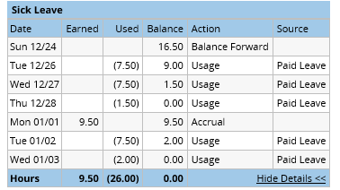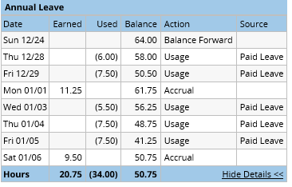

Click on Results.

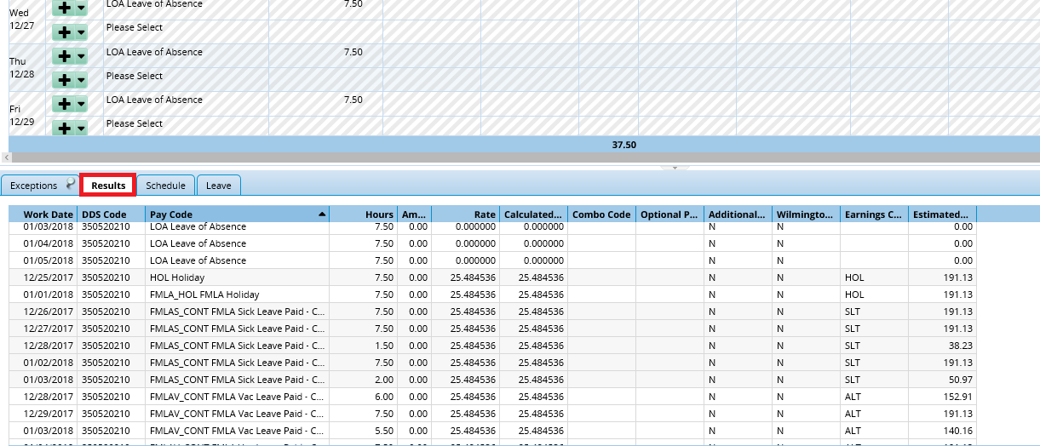

The results tab displays the LOA code and the leave that you used each day. Click on the far right arrow. Uncheck the Work Date box.

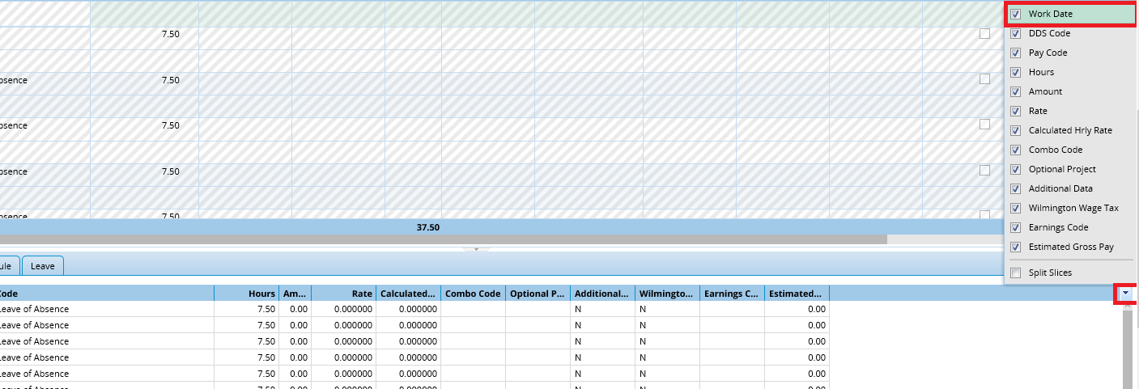

Unchecking this box will display the total amount of leave paid for each pay cycle.

